**Department Notification Management System(DNMS)**

**Problem Statement:** The Common Problem that Students are facing now-a-days in many colleges is that there is no direct communication between students and higher Authorities like Director, Principal , Department HODs and Faculty. One of the main issues, ‘**delay in getting information**’.

**Solution:** Department Notification Management System(DNMS), A Web application, Which can be helpful to solve this issue. DNMS solves the mentioned issue by acting as an interface between the students and faculty. The Workflow of DNMS is

**Home page:**

After opening the website , you will be able to see the website home page where you can find the options for register and login. Also you will be able to see recent or new notifications if any. The home page is shown in fig1.

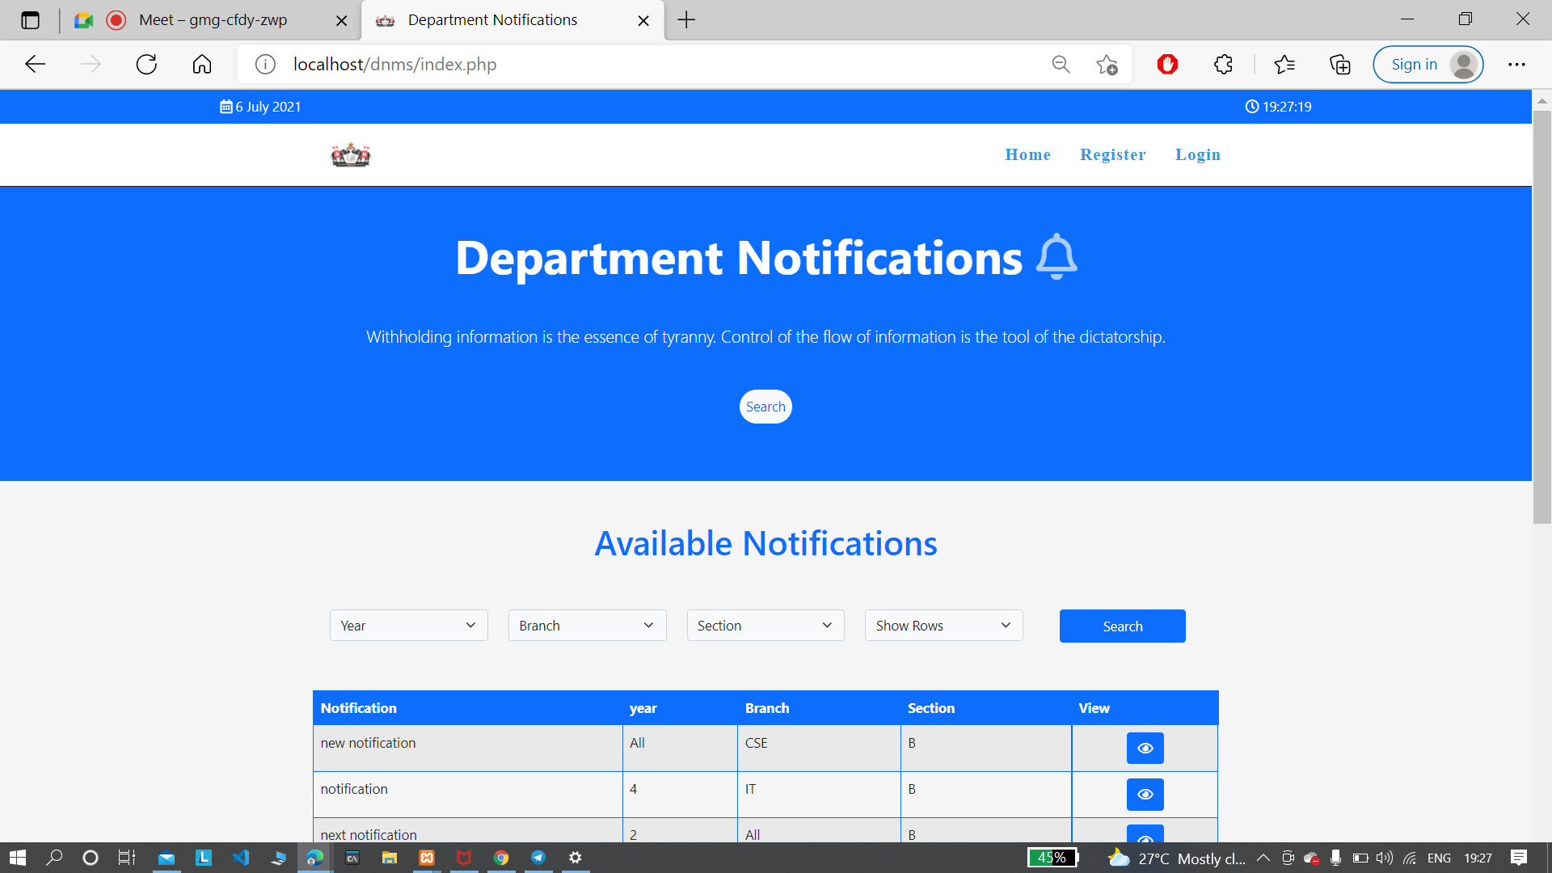

Fig 1. Home page

Recent notifications can be seen by the students after login to the website. And they can filter the notifications using the options above the table in fig 1. Filtering options are year, branch, section. And you can set how many rows you want to see using the show rows option.

If you click on the register button, you will be redirected to the register page where you can find registration forms for faculty and students. For registering, students and faculty get two different fields to be filled respectively. For Faculty the respective fields need to be filled as Faculty Name, Faculty Id, Email, Contact no, Degree, Password and Confirm password and get registered. The Faculty registration Form is shown in fig2.

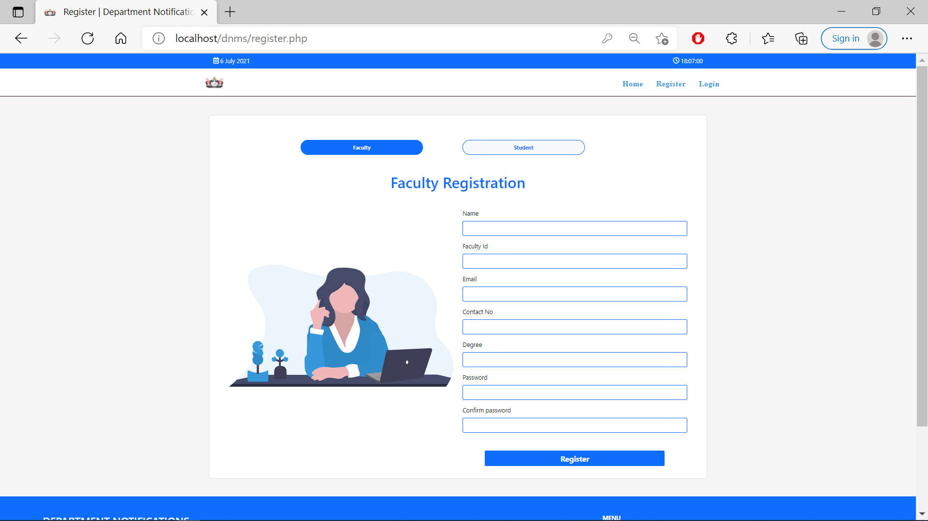fig2. Faculty registration page

For students the respective fields need to be filled as Name, Email, Contact no, dob, Roll no, Year, Branch, Section, Password and confirm password and get registered. The Student registration Form is shown in fig3.

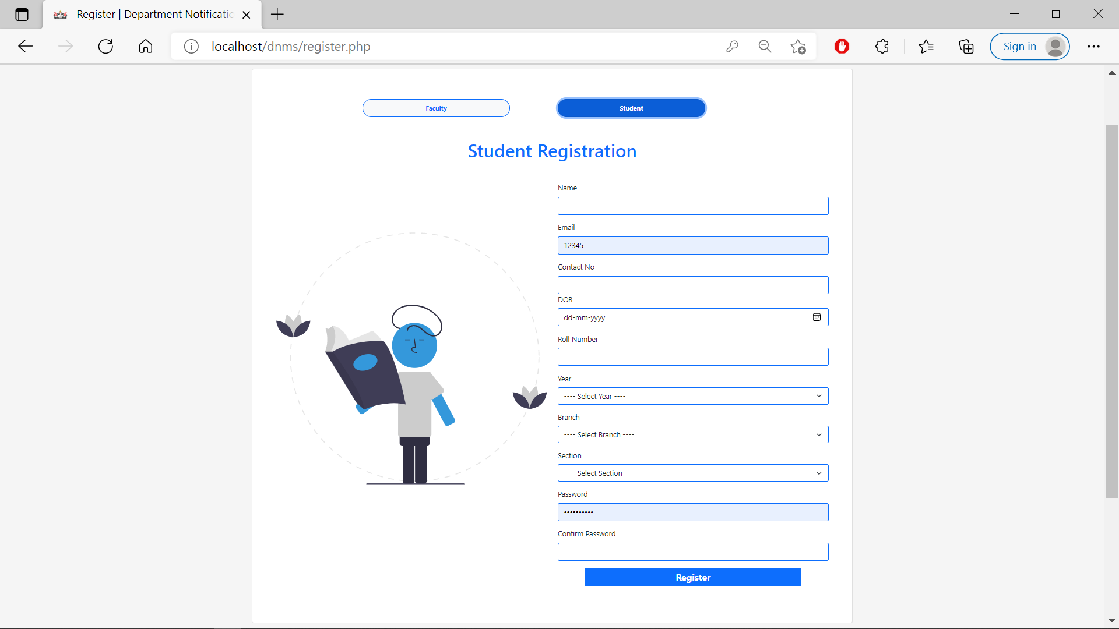

Fig3. Student Registration Form

After registration, you will be redirected to the login page through which you can login to the website using ID, Password, Selecting Login whether as student or faculty. Else, the next option in the home page is login. If you have already registered then you can login using this button. The login page shown in fig4.

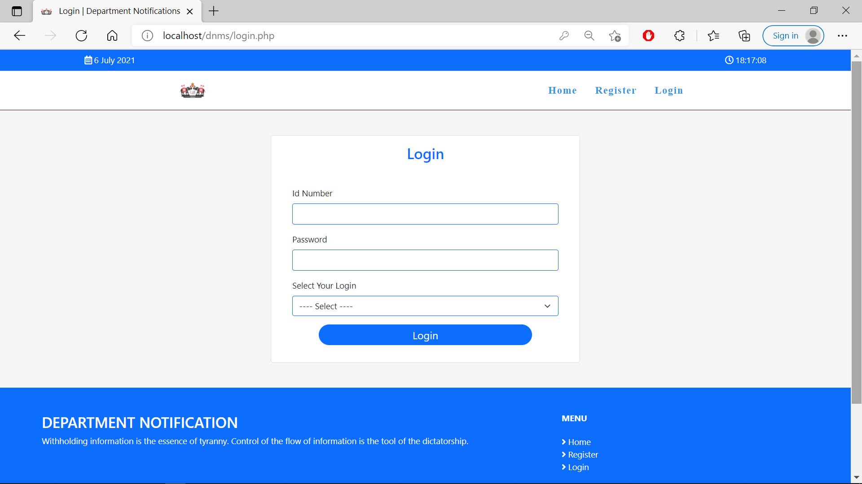

Fig4. Login Page

**Faculty dashboard**:

After login to the website as Faculty, you will be able to see the dashboard which contains

Profile, Add Notifications , Change Password and My Notifications sections.

In the profile section, faculty will be able to see their details and they can update their profile whenever they want except their Id. The page looks like the one shown in fig5.

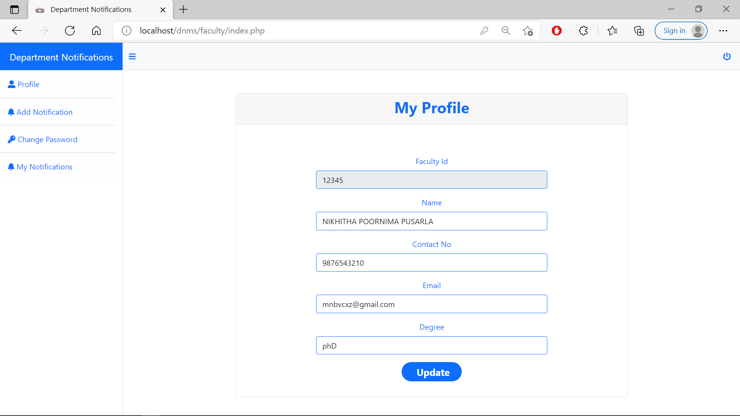

Fig5. Faculty Dashboard

In the Add Notifications section, they will be able to see the page shown in fig6.

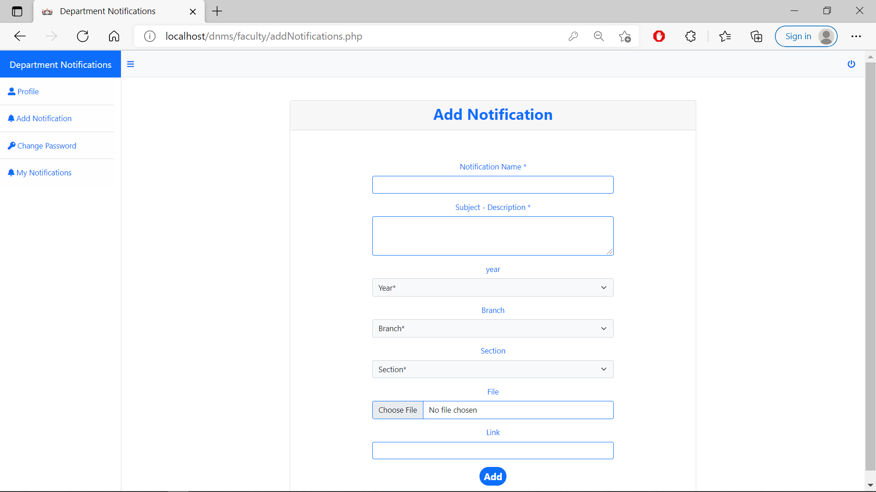

Fig6. Add notifications Section

In this section, all options must be filled except file and link. File and Link options are optional. These notifications will be stored in the table which is in the Home page of the website.

The next section is the Change Password section, In which faculty can change their password. It looks like the one shown in fig7.

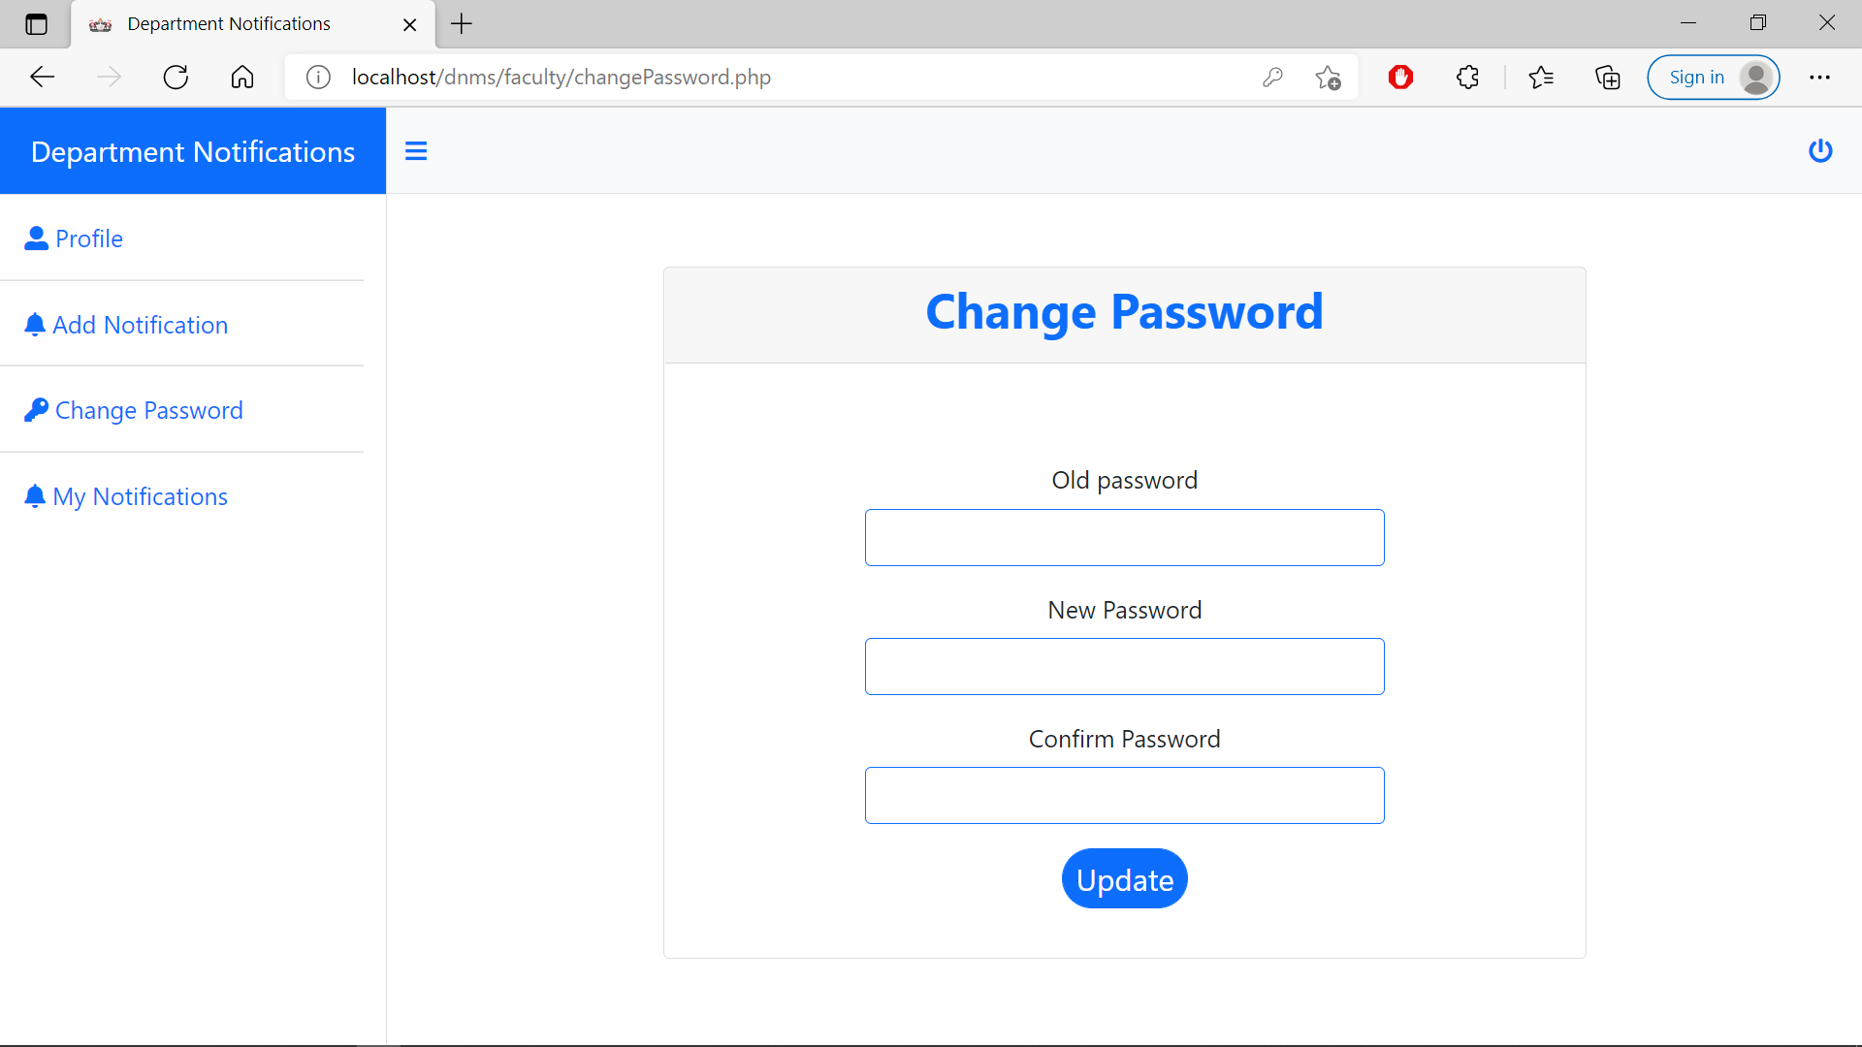

Fig7. Change password section

The next section is My Notifications section, In which faculty can delete or edit the notifications if there is any need for that. They can filter through the options given above the table by choosing year , branch , section , etc.

This section looks like the one shown in fig8.

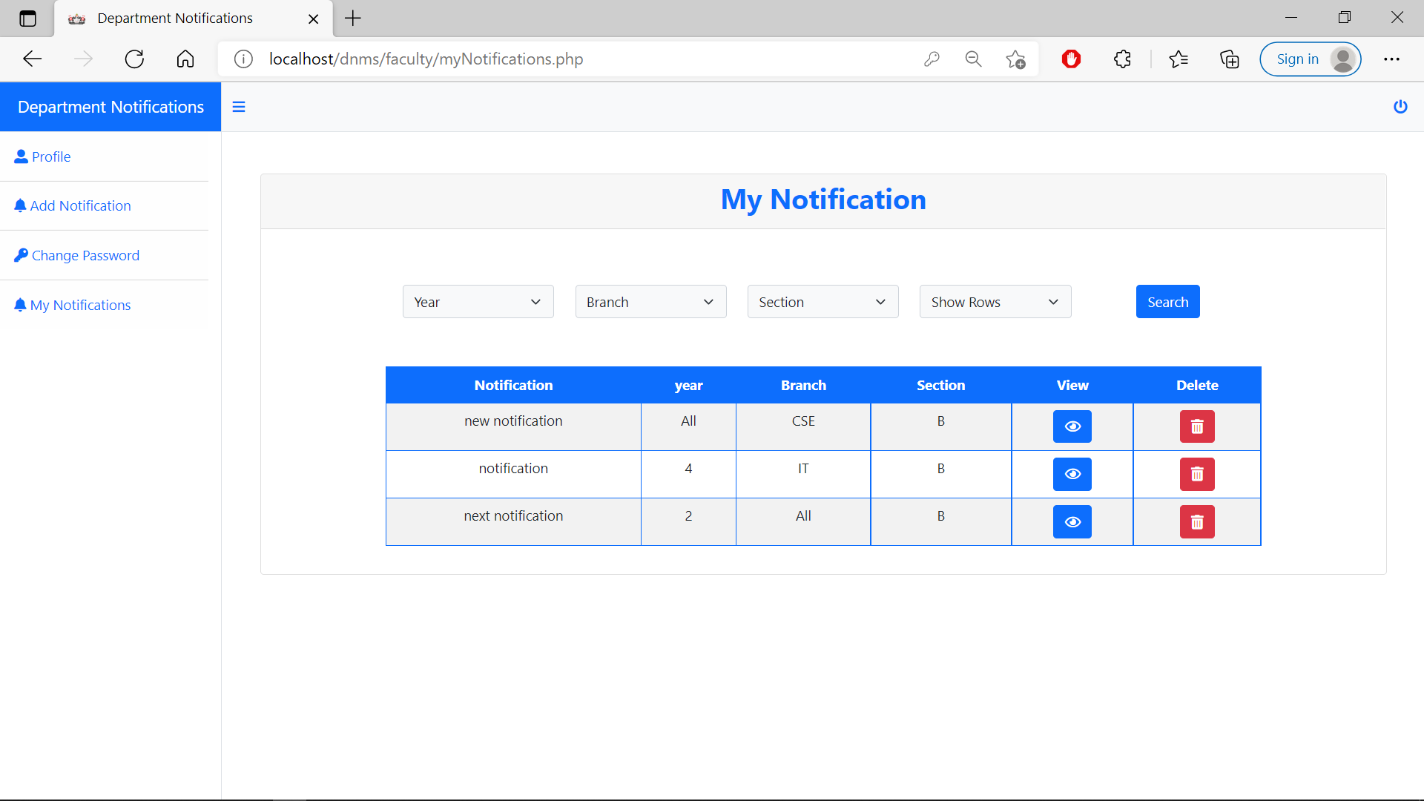

Fig8. My Notifications section

After logging in, students will be redirected to the home page where they can find Home, Change password, Profile, Logout options.

In the home page,there will be a page of Available notifications by searching Year, Branch, Section, Show rows.When you click the search button the available notifications will appear based on the above search results.If there was nothing related to the above searched results it results as No Data Found!.

If any notifications are there, one can see them as shown in figure9.

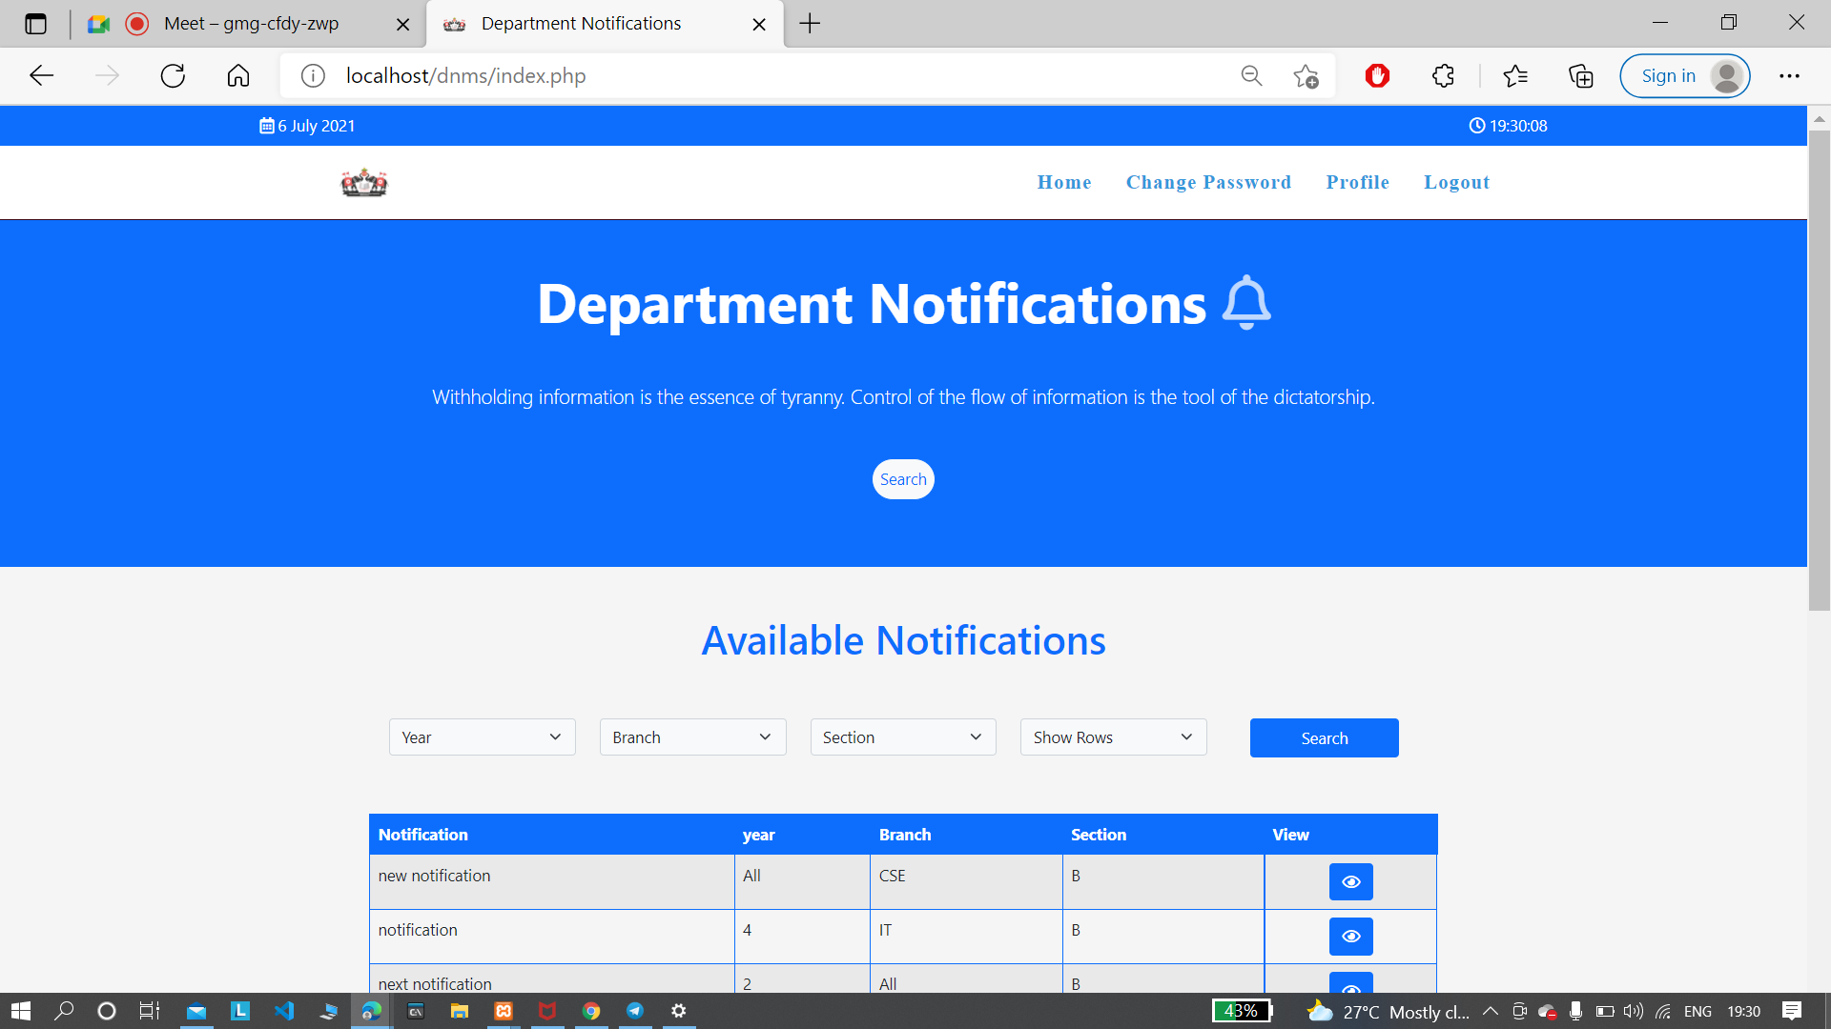

Fig9. student’s Home Page

If they click on the view button then it will be redirected to another page containing the information. That page will look like the one in fig 10.

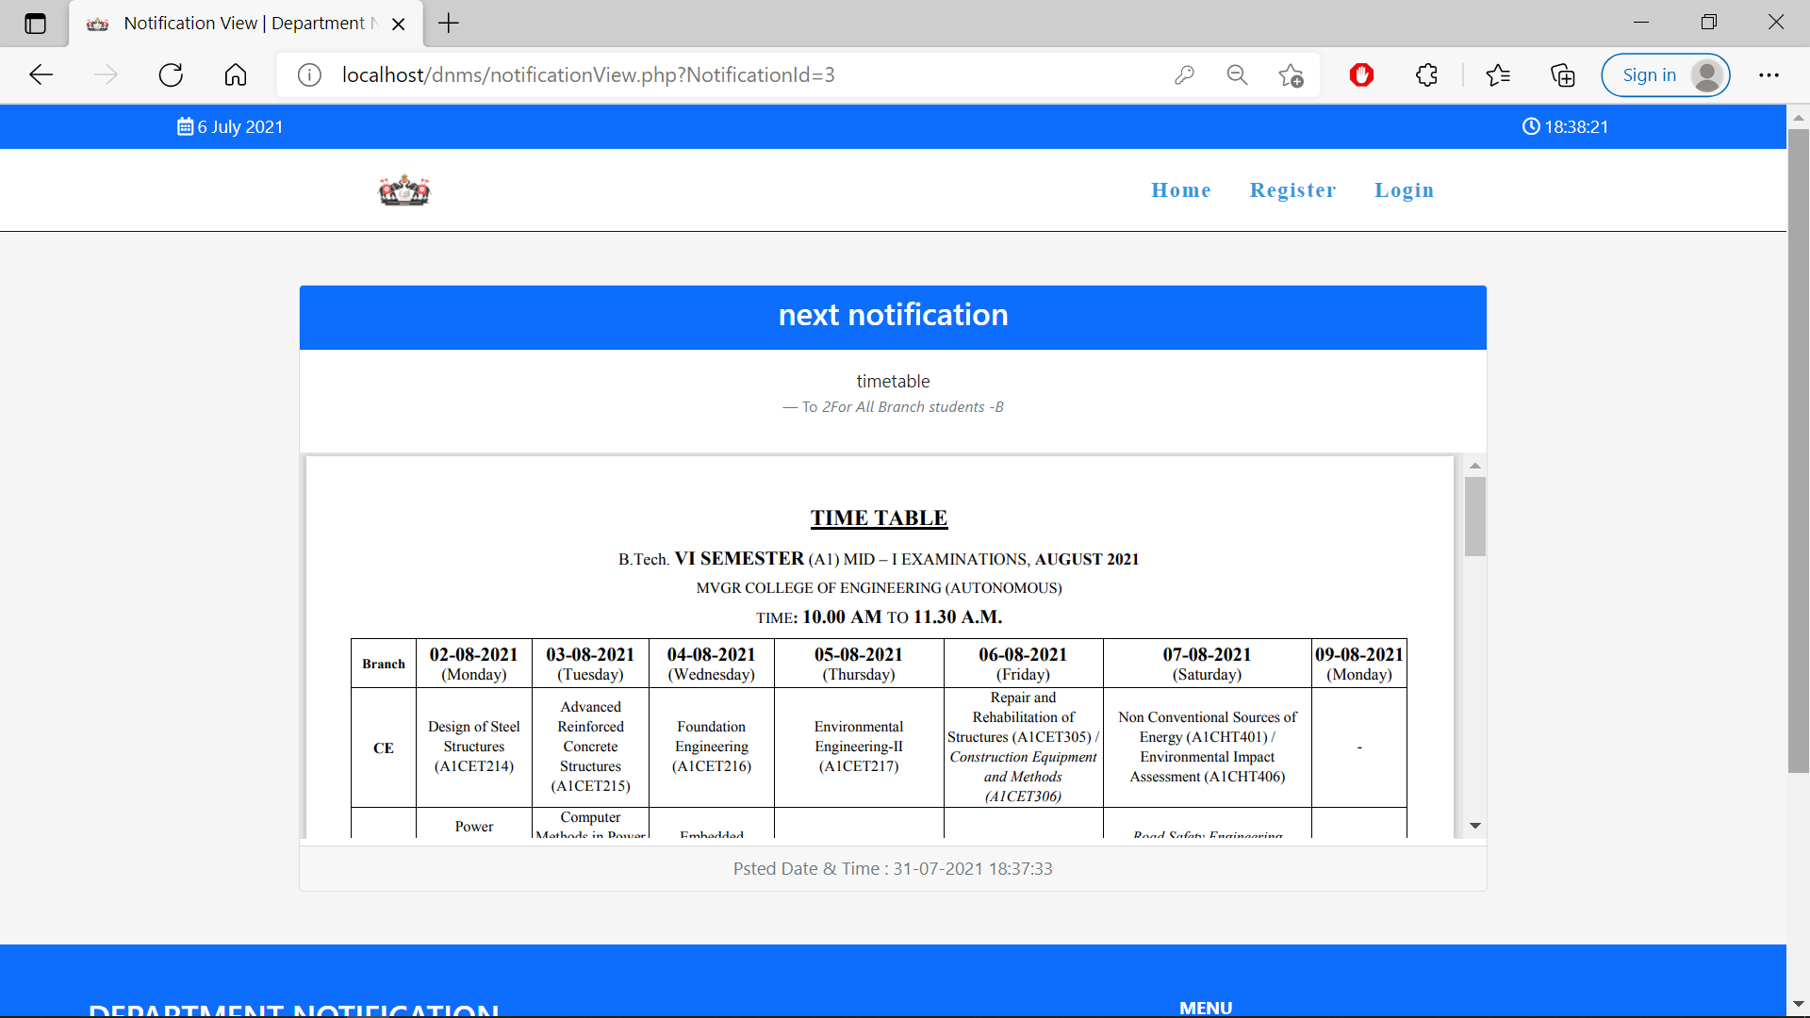

Fig10. View notifications page

The Change Password section for students is the same as the faculty’s Change Password section.

In the profile page,the student profile appears and in that page if there is any updations required regarding to the students profile, they can update their profile.In the receiver page the categories appear as Student Id, Name, Email, Contact No, Year.After clicking the Update button the details get updated. This page is shown in fig11.

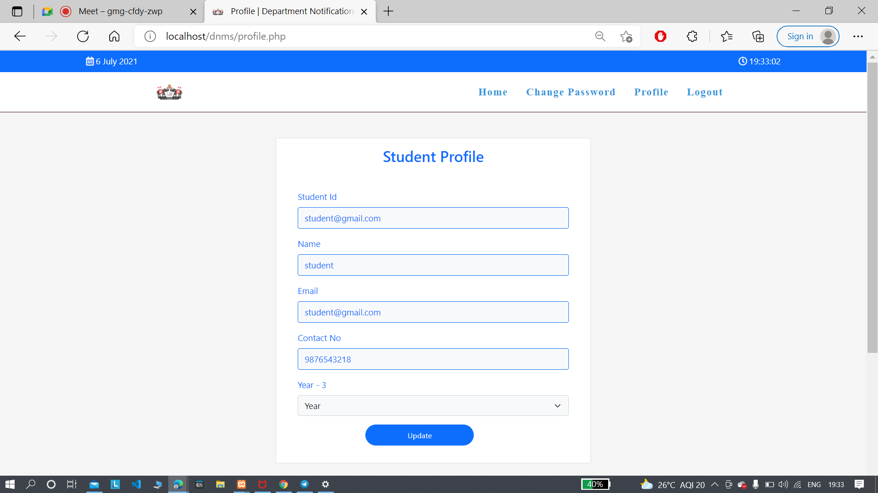

Fig11. Student’s Profile Page

In the logout section by clicking the logout button,again you will be redirected to the registration page.

**Technologies Used:**

**Front-end:** HTML , CSS, JS, BOOTSTRAP

**Back-end:** PHP

**Data base:** MYSQL